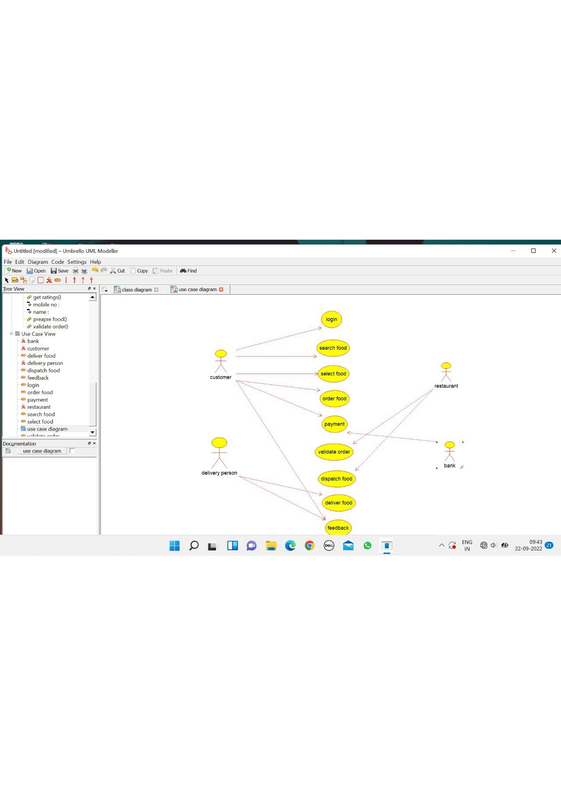

CUSTOMER

/**

* Class customer

*/

public class customer {

//

// Fields

//

private void name;

private void mobile_no;

private void email_id;

private void address;

//

// Constructors

//

public customer () { };

//

// Methods

//

//

// Accessor methods

//

/**

* Set the value of name

* @param newVar the new value of name

*/

private void setName (void newVar) {

name = newVar;

}

/**

* Get the value of name

* @return the value of name

*/

private void getName () {

return name;

}

/**

* Set the value of mobile_no

* @param newVar the new value of mobile_no

*/

private void setMobile_no (void newVar) {

mobile_no = newVar;

}

/**

* Get the value of mobile_no

* @return the value of mobile_no

*/

private void getMobile_no () {

return mobile_no;

}

/**

* Set the value of email_id

* @param newVar the new value of email_id

*/

private void setEmail_id (void newVar) {

email_id = newVar;

}

/**

* Get the value of email_id

* @return the value of email_id

*/

private void getEmail_id () {

return email_id;

}

/**

* Set the value of address

* @param newVar the new value of address

*/

private void setAddress (void newVar) {

address = newVar;

}

/**

* Get the value of address

* @return the value of address

*/

private void getAddress ()

DELIVERY PERSON

/**

* Class delivery_person

*/

public class delivery_person {

//

// Fields

//

private void mobile_no;

private void id;

//

// Constructors

//

public delivery_person () { };

//

// Methods

//

//

// Accessor methods

//

/**

* Set the value of mobile_no

* @param newVar the new value of mobile_no

*/

private void setMobile_no (void newVar) {

mobile_no = newVar;

}

/**

* Get the value of mobile_no

* @return the value of mobile_no

*/

private void getMobile_no () {

return mobile_no;

}

/**

* Set the value of id

* @param newVar the new value of id

*/

private void setId (void newVar) {

id = newVar;

}

/**

* Get the value of id

* @return the value of id

*/

private void getId () {

return id;

}

//

// Other methods

//

/**

*/

public void collect_food()

{

}

/**

*/

public void deliver_food()

{

}

/**

*/

public void get_feedback()

{

}

}BANK

/**

* Class bank

*/

public class bank {

//

// Fields

//

private void name;

//

// Constructors

//

public bank () { };

//

// Methods

//

//

// Accessor methods

//

/**

* Set the value of name

* @param newVar the new value of name

*/

private void setName (void newVar) {

name = newVar;

}

/**

* Get the value of name

* @return the value of name

*/

private void getName () {

return name;

}

//

// Other methods

//

/**

*/

public void transasction()

{

}

/**

*/

public void refund()

{

}

}

RESTAURANT

/**

* Class restaurant

*/

public class restaurant {

//

// Fields

//

private void name;

private void address;

private void mobile_no;

//

// Constructors

//

public restaurant () { };

//

// Methods

//

//

// Accessor methods

//

/**

* Set the value of name

* @param newVar the new value of name

*/

private void setName (void newVar) {

name = newVar;

}

/**

* Get the value of name

* @return the value of name

*/

private void getName () {

return name;

}

/**

* Set the value of address

* @param newVar the new value of address

*/

private void setAddress (void newVar) {

address = newVar;

}

/**

* Get the value of address

* @return the value of address

*/

private void getAddress () {

return address;

}

/**

* Set the value of mobile_no

* @param newVar the new value of mobile_no

*/

private void setMobile_no (void newVar) {

mobile_no = newVar;

}

/**

* Get the value of mobile_no

* @return the value of mobile_no

*/

private void getMobile_no () {

return mobile_no;

}

//

// Other methods

//

/**

*/

public void validate_order()

{

}

/**

*/

public void dispatch_food()

{

}

/**

*/

public void preapre_food()

{

}

/**

*/

public void get_ratings()

{

}

}

